|  |  |  |
| --- | --- | --- |
| **Sl. no** | **Content** | **Page. no** |
| 1 | Abstract | **1** |
| 2 | Introduction | 2 |
| 3 | Background of the Study | 3 |
| 4 | Problem statement | 3 |
| 5 | Objective | 4 |
| 6 | Scope | 4 |
| 7 | Limitations | 4 |
| 8 | Assumption and hypothesis | 5 |
| 9 | Signification of the problem | 5 |
| 10 | Definition of terms | 6 |
| 11 | Review of Introduction | 6 |
| 12 | Introduction | 7 |
| 13 | Literature survey | 7 |
| 14 | Methods and procedures | 8 |
| 15 | Theoretical Framework | 9 |
| 15 | Proposed system | 11 |
| 16 | Conclusion |  |

* **Abstract:**

Blood transfusion safety is a relevant and significant public health issue in the Sultanate of Oman. Since most blood banks are still in paper-based system, various disadvantages are experienced by various stakeholders, which endanger the lives of patients and deter the healthcare system. As such, the researchers aimed to design, develop, and implement an online blood bank management system (OBBMS). This web-based application allows hospitals in Oman to make inventories of their blood bags online, subsequently, allowing each hospital to check the availability of blood bags anytime. The researchers designed and administered a questionnaire that assess the perceptions of various stakeholders in both manual-based and OBBMS. Based on the findings and results, it was found out that these stakeholders perceived online blood bank management system is much better than the manual system. Therefore, with the use of online blood bank management system, blood transfusion process is safe and secured. Threats on improper blood donor documentation, or misplaced records will be totally eradicated. Also, processes involving recording about blood donors, blood bag collection, storage, and inventory will be systematized and organized, hence, improving the healthcare management for blood banks.

**Key words:** Online Blood Bank Management System, Blood Bank Management, Blood Donation, Blood Transfusion Safety, Web-Based Application

* **Introduction:**

Blood transfusion safety remains an important public health concern in Oman. The availability of blood products of all blood types and the provision of its safety ensure public trust of its excellent healthcare system. However, lack of availability of these blood products and provision of unsafe blood products still impact morbidity and mortality in the Sultanate. Through the use of online blood bank management system, blood transfusion safety is expected to be enhanced or improved. Risks on improper blood donors’ documentation, and misplaced records can be minimized or totally avoided. Also, processes involving blood bag collection, storage, and inventory will be systematized and organized, hence, improving the healthcare management. devices such wireless sensors for further processing in the Cloud. The suggested system uses the Representational State Transfer (REST) concept. It performs well in terms of scalability and response speed. Experiments confirmed the effectiveness of the suggested system even more.

* **Background of the Study**

For hospitals, a blood bank known as blood collection centre, also is an area in which collected blood bags are stored and preserved for future use in blood transfusion services. Blood transfusion is a medical operation where a patient requires blood or blood products as a life saving measure. . In an article1 published in Times of Oman in 2014, it was reported by Ministry of Health that the total amount of blood donated annually in Muscat is approximately 25,084 units.further reported that its Department of Blood Services is functioning at full capacity to meet the demands in the Sultanate.

Most blood banks are still running manual system in its processes. As such, there is a lack of efficiency because it is still paper-based in collecting information about donors, inventories of blood bags, and blood transfusion services. The lack of proper documentation may endanger patients’ health due to the possibility of having contaminate blood bags. Contamination happened when there is an incomplete donors’ medical history record and the blood bags’ shelf life is not monitored properly. Hence, a web-based blood bank management system might be needed to address these issues and problems encountered to ensure blood transfusion safety.

* **Problem Statement :**

Despite advances in technology, nowadays, most blood bank systems are running in manual system. As such, there is a prevalent problem in the availability of needed blood types. For instance, when a person needs a certain type of blood and this type is not available in the hospital, family members send messages through social media to those who can donate to them and this process takes longer than the life of the patient to the most dangerous. In addition, it seems that there is lack of proper documentation about blood donors and its medical history. This may lead to blood bag contamination and may affect the blood transfusion safety. Generally, this study aims to determine how the use of online bank management system enhance blood transfusion safety. Subsequently, this study seeks to answer the following specific problems:

1. What is the level of perception among blood bank’s stakeholders on manual-based system?
2. What is the level of perception among blood bank’s stakeholders on online blood bank management system?
3. H0: Is there no significant difference in the level of perception among stakeholders between manual-based and online-based blood bank system?
4. H1: Is there a significant difference in the level of perception among stakeholders between manual-based and online-based blood bank system?

* **Objective:**

This applied research aims to design, develop and implement online blood bank management system. This web-based application provides:

* To ensure hospital to have good supply or inventories of blood bags.
* To check the availability of blood bags anytime.
* To manage the information of its blood donor.
* Function to check if the person donate blood for the last 3 months.
* To allow good documentation about the donor and its blood donation activities.
* Support fast searching to find match blood bags for the right person.
* **Scope:**

This research study covers the three (3) basic operations of blood banks, namely: donor registration, monitoring of blood bags or products’ inventories, and monitoring of blood bags or products’ issuance. Also, due to time-constraint, respondents will be from hospitals from North Batinah Region in the Oman, though the research study talks about blood banks in the Sultanate of Oman. In addition, the study considers three (3) possible users of the system, namely: hospital administrator, doctors, and blood receptionists.

* **Limitation:**

This research study does not cover the actual blood collection activity, and actual blood transfusion operation. Blood donors and patients or recipients of blood donation are not system users, their registration or information will be encoded by the blood bank receptionists.

* **Assumptions and Hypothesis:**

The researchers assume the following assumptions:

1. Internet connectivity is needed for the online blood management system. Internet speed may affect the perception of the systems users with regards to the system effectiveness and efficiency.
2. Blood transfusion should be performed by medical or professional doctors only. The over-all safety depends on the success of the medical operation.

The researchers identify the following hypotheses:

1. There is a significant difference in the level of blood transfusion safety between manual-based and online blood bank systems.
2. There is an increased level of blood transfusion safety in using online blood bank management systems while there is an increased risk when using manual-based one.

* **Significance of the problem :**

The findings of this study will benefit blood banks in managing blood donation donors, activities, and blood bags. This will allow the hospital to take decision if a particular type of blood is needed and currently unavailable in the hospital, however, available in another nearby hospitals. Furthermore, managing the blood bags in the blood bank will be much easier because each blood bag has an information about the donor, donation activity details, and the expiration date. Also, doctor can use this system to serve blood bags to their patient and monitor the details of the donor.

The main advantages of the system are:

* Blood bank staff can find and manage the donor details on the system easily.
* The expiration date of blood bags can be viewed in the system.
* Hospital can be alerted about issued blood bags and its availability.
* The system is systematized, and organized in managing blood donor records and blood donation activities.
* **Definition of terms :**
* **Blood bags** are designed for the collection, processing and storage of whole blood and blood components. They help in providing aseptic conditions for the separation of blood components. It acts as a closed system reducing the chances of contamination.
* **Blood bank** is a place where blood bag that is collected from blood donation events is stored in one place. Which refers to a division of a hospital laboratory where the storage of blood product occurs and where proper testing is performed to reduce the risk of transfusion related events.
* **Donor** is someone who gives a part of their body or some of their blood to be used by doctors to help a person who is ill.
* **Transfusion**: transfusion is done as a lifesaving manoeuvre to replace blood cells or blood products lost through severe bleeding. Transfusion of one's own blood (autologous transfusion) is the safest method, but it requires advanced planning, and not all patients are eligible.
* **Review of Introduction :**

This section discusses findings and observations done by some research works on web based blood bank management system. The gathered information on these related papers strengthens and supports the research study.

* **Literature Survey:**

According to in their study entitled “***A Study on Blood Bank App***”**,** they defined Blood Bank Information System as an information management system that contributes to the management of donor records and blood bank. Their system allowed an authorized blood bank administrator to sign in with a password to manage easily the records of donors and patients who need blood. The system provided many features including the central database, quick access to the system content through the login, includes the search code to find donors on a given basis, and the ease of adding and updating donor data. The main aim of the system was to complete0the process of the blood bank.

On the other hand, study entitled ***“Blood Bank App management system”*** done by the researchers developed a web-based blood management which assists the blood donor records management, and provides ease of control in the distribution of blood products in various parts of the country considering demands of hospitals. The developed system was scalable and adaptable to meet the complex needs usually of a blood bank. Based on this study, since entering the details about the blood donors and related records were done manually, thus, tracking of blood donation activities was difficult and complicated, and even led to erroneous information. Subsequently, the researchers mentioned that manual-based system can be waste of time, lead to the error-prone results, consumes a lot of manpower, lacks data security, data retrieval requires a lot of time, reports consumes a long time to produce, and there is less precise accuracy on the results. As such, by developing and implementing a web-based blood management information system, there was a quick and timely access to donor records, and the system provided management timely, confidential and secured medical reports. There were three (3) users in the system, namely: Administrator, Donor, and Acceptor. Each user has been given user ID and password to identify their identity. The said application was developed using react, MongoDB and using the research paper failed to mention the methods of research used.

In this study, the researchers learnt the importance of implementing a web-based blood bank management system in handling records for blood donors and blood donation activities to ensure accurate and readily available information for blood transfusion services. Indeed, the impact of using Information Technology on hospitals provides better healthcare services for the public. Likewise, the researchers learnt that there are programming languages suitable for web-based applications such as react, MongoDB

In the study entitled “***Blood Bank App management system***”it found out that it is important for every hospital to use an information system to manage data in blood bank. Also, it observed that the manual system has disadvantages for the user and the hospital. One of the disadvantages identified was the blood bank staff should enter the donor details in each time he/she donate blood in which led to duplicate data of the donor and also the data may be lost or missing after period of time. Thus, the author developed a web-based system to help the blood bank to record the donor details fast and easy. The system used rule-based decisions to ensure to have a right decision on right time. Also, system can send messages to donors if any particular blood type is needed. She developed blood bank system based on incremental model. She had chosen this model because the system can be developed through cycle of phase and also because of the advantages of this model such as:

1. Easy to understand to flow of the phases.
2. Changes possible in the middle of any phases.
3. The system can be developed even if there is an error in the middle and it can be corrected in testing phase.

In this study, the researchers observed that the developer failed to include in the system the function to check the availability of blood bags, and to check the shelf life or expiration of blood bags or products. As such, the researchers will include these in their developed system to enhance safety for blood transfusion.

* **Methods And Procedures:**

This section presents the research methodology used in the study, the research design, and the data collection process. This section also presents the theoretical or conceptual framework of the study, the sampling plan, and tools to be used for data analysis.

* **Theoretical Framework:**

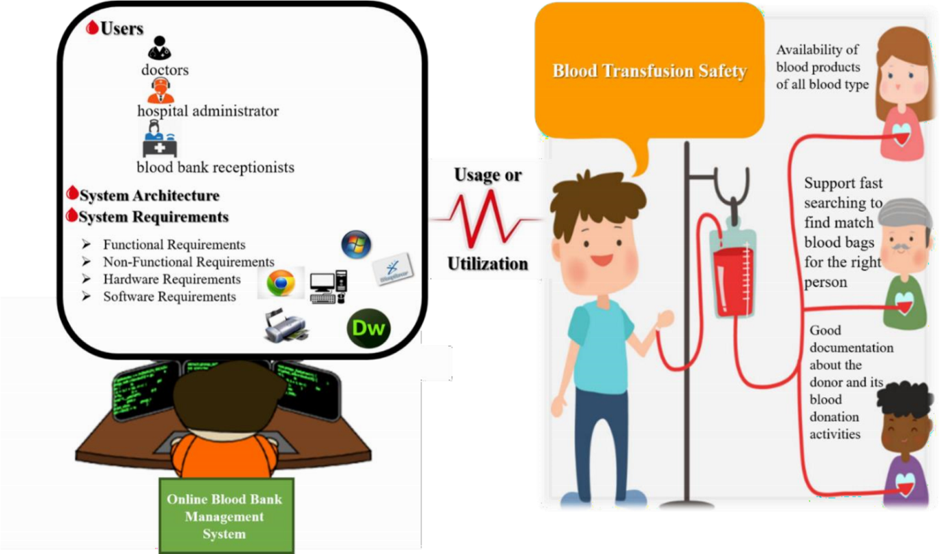

Theoretical Framework

The conceptual framework served a mental window of the researchers because it depicted the research design and the relationships of the variables involved. Based on the figure above, the usage or utilization of the online blood bank management system can lead to the enhancement or improvement of blood transfusion safety.

* **Methods and Procedures :**

The researchers used both descriptive research and experimental research design methods. The study was descriptive because it describes the nature of situation as it exists at the time of the study. Also, it was a systematic and scientific approach to research in which the researchers manipulate one or more variables, and control and measure any change in other variables. It involves collection of data in order to test hypotheses or to answer questions concerning current status of the subject of the study. The study was also experimental because it has an assumption of a cause-and-effect relationship, and the researchers introduce online blood bank management system as intervention that caused the change.

In this study, the researchers used questionnaire to collect information and to obtain the perception of the various stakeholders on how they perceive the manual-based system and the online system. The questionnaire was administered to hospital administrators, doctors, and blood bank receptionists. In sampling, the researchers used cluster sampling in which respondents were grouped according to their roles and responsibilities. The questionnaire includes 18 questions. There were many strategies to analyse data after collected. The researchers counted the frequency of each question, and computed the mean as a measure of central tendency. Also, standard deviation and variance were calculated to perform the t-test. From the mean or average of both manual based system and online system, the researchers compared the computed mean to see if the use of online system is much better than manual system. Also, from the result of t-test, the researchers decided if the null hypothesis will be accepted or not.

* **Proposed System:**

The researchers were able to design, and develop an online blood bank management system using React and MongoDB for the back-end front end database. Below are sample screenshots of the

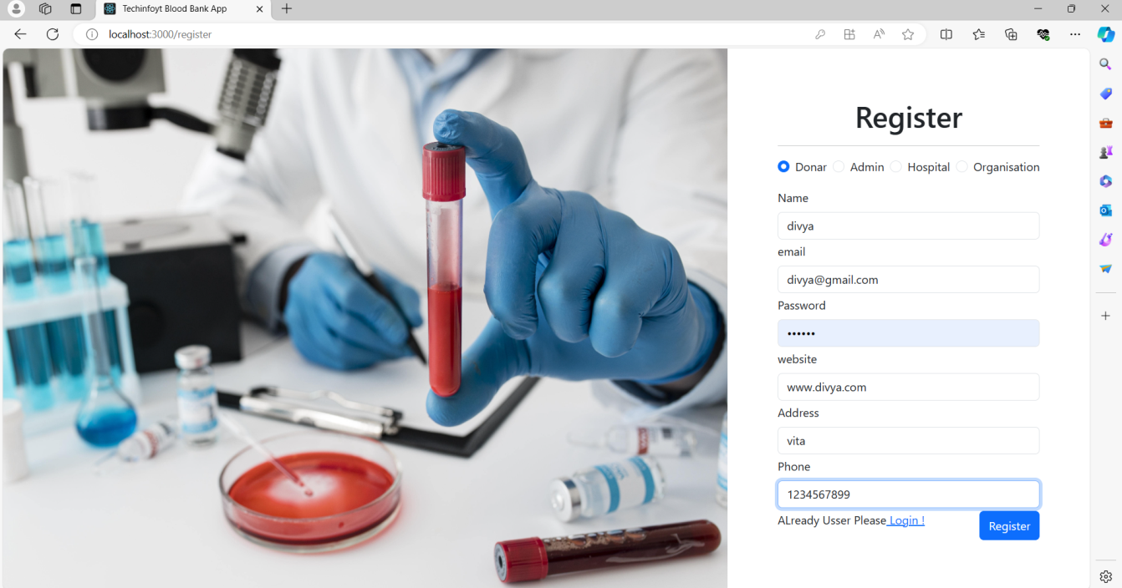

**Figure1.1: Register page**



**Figure1.2: Registered Successfully**



**Figure2.1: Login page**

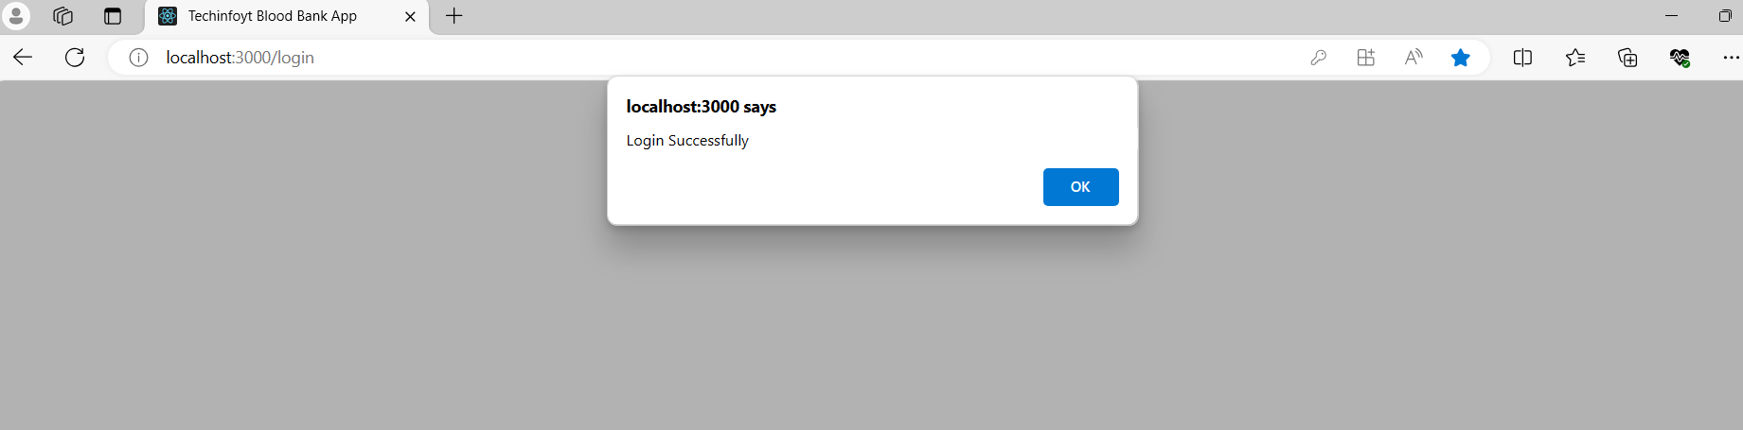

**Figure2.2: Login page successfully**

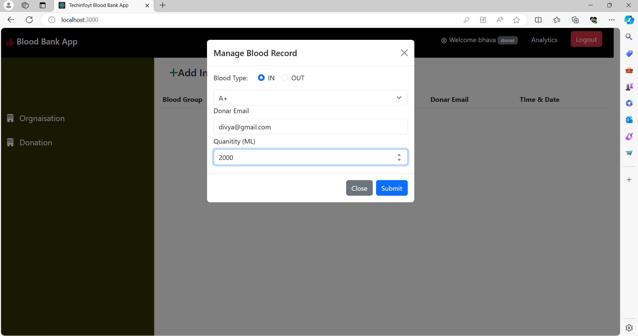

**Figure3.1: Blood Record**

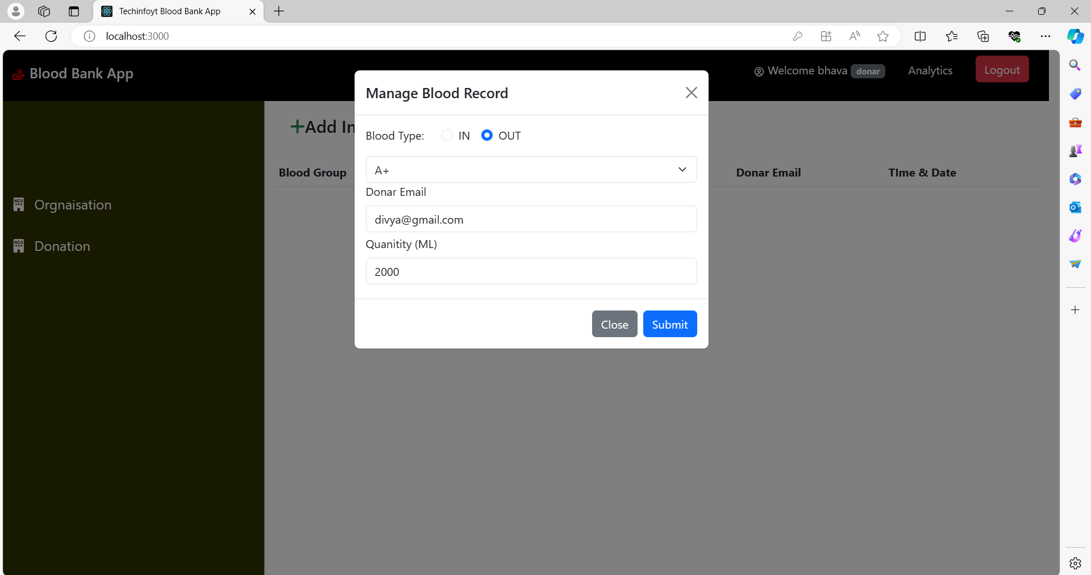

**Figure3.2: Blood Record**

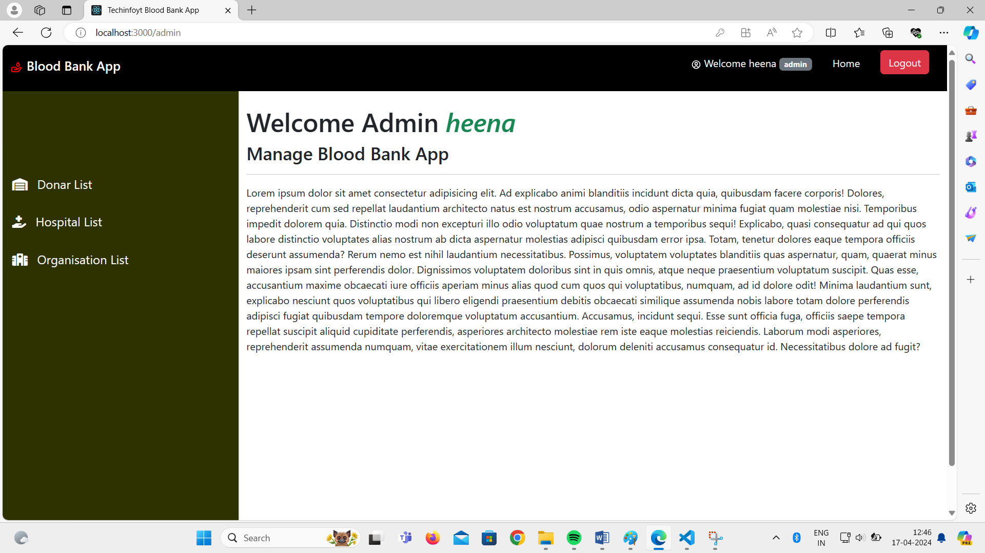

**Figure4.1: Admin page**

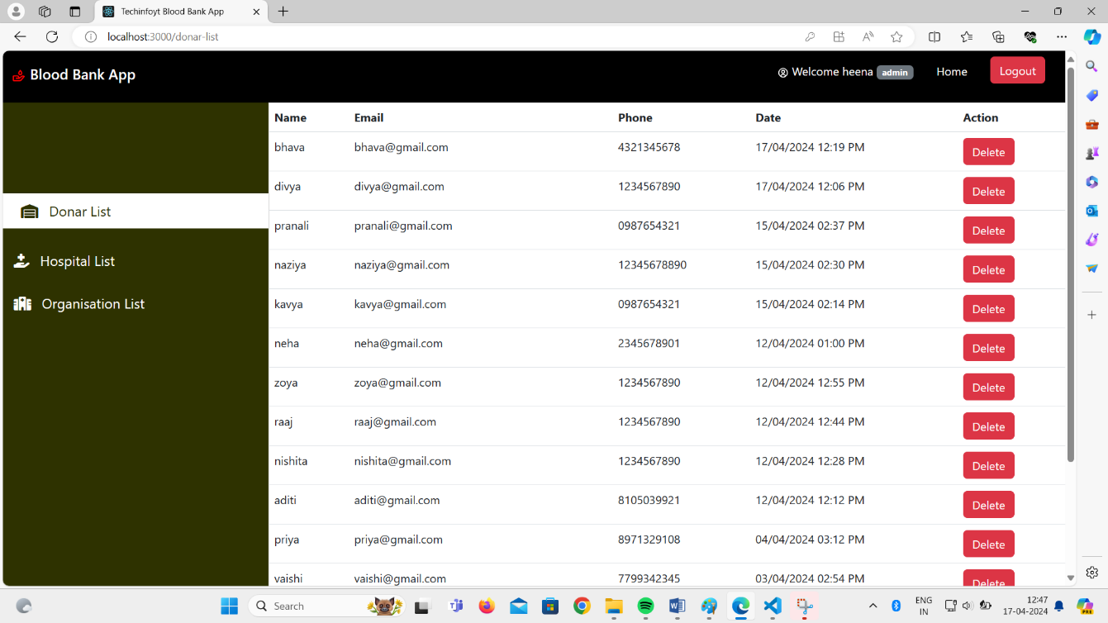

**Figure4.2: Donar List**

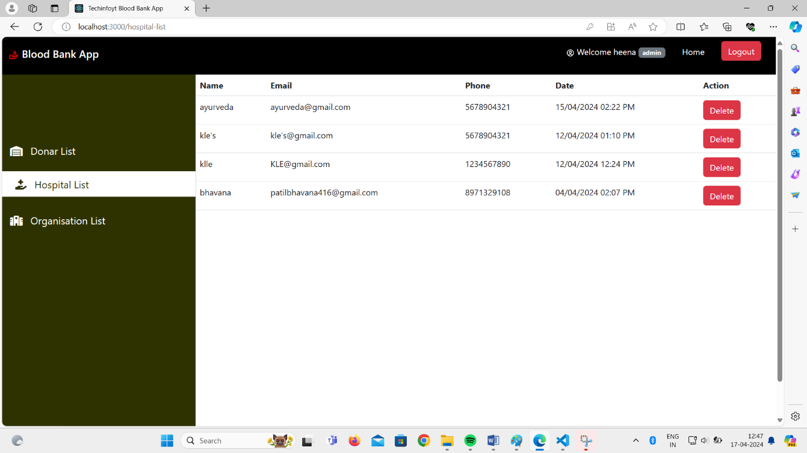

**Figure4.3: Hospital List**

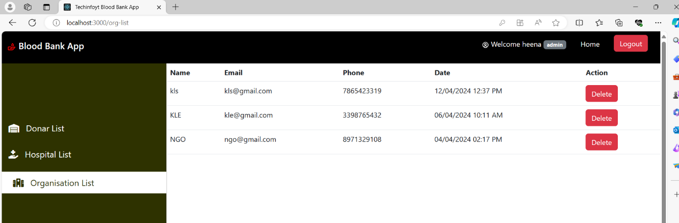

**Figure4.4: Organization List**



**Figure5.1: Hospital Login page**

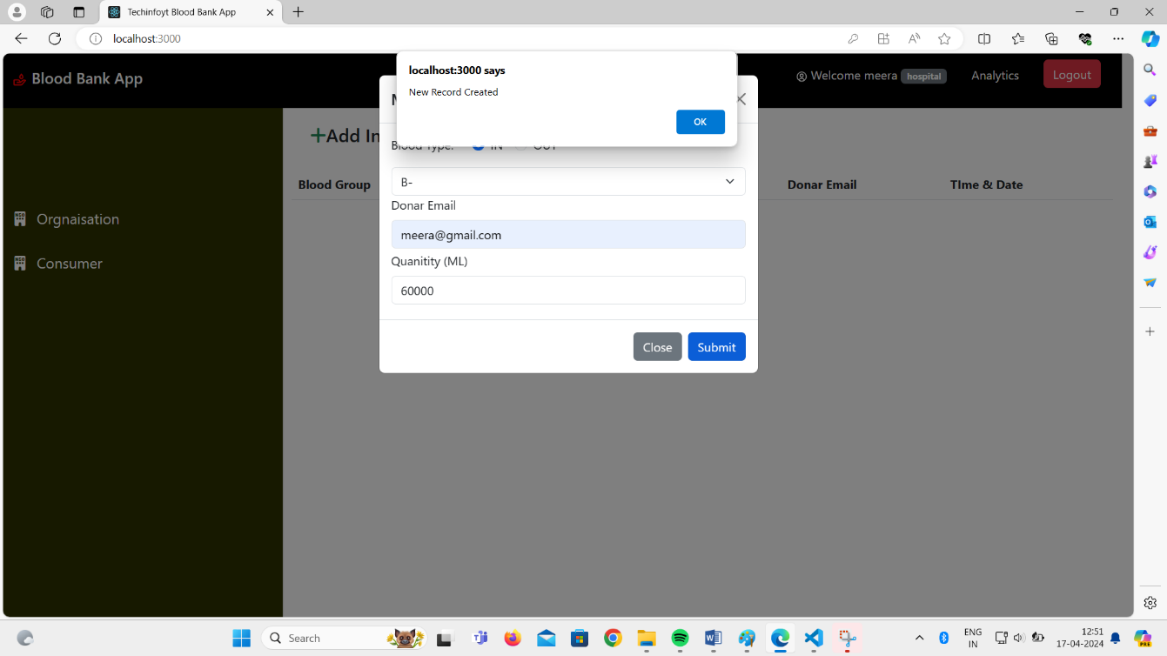

**Figure5.2: Hospital Record**

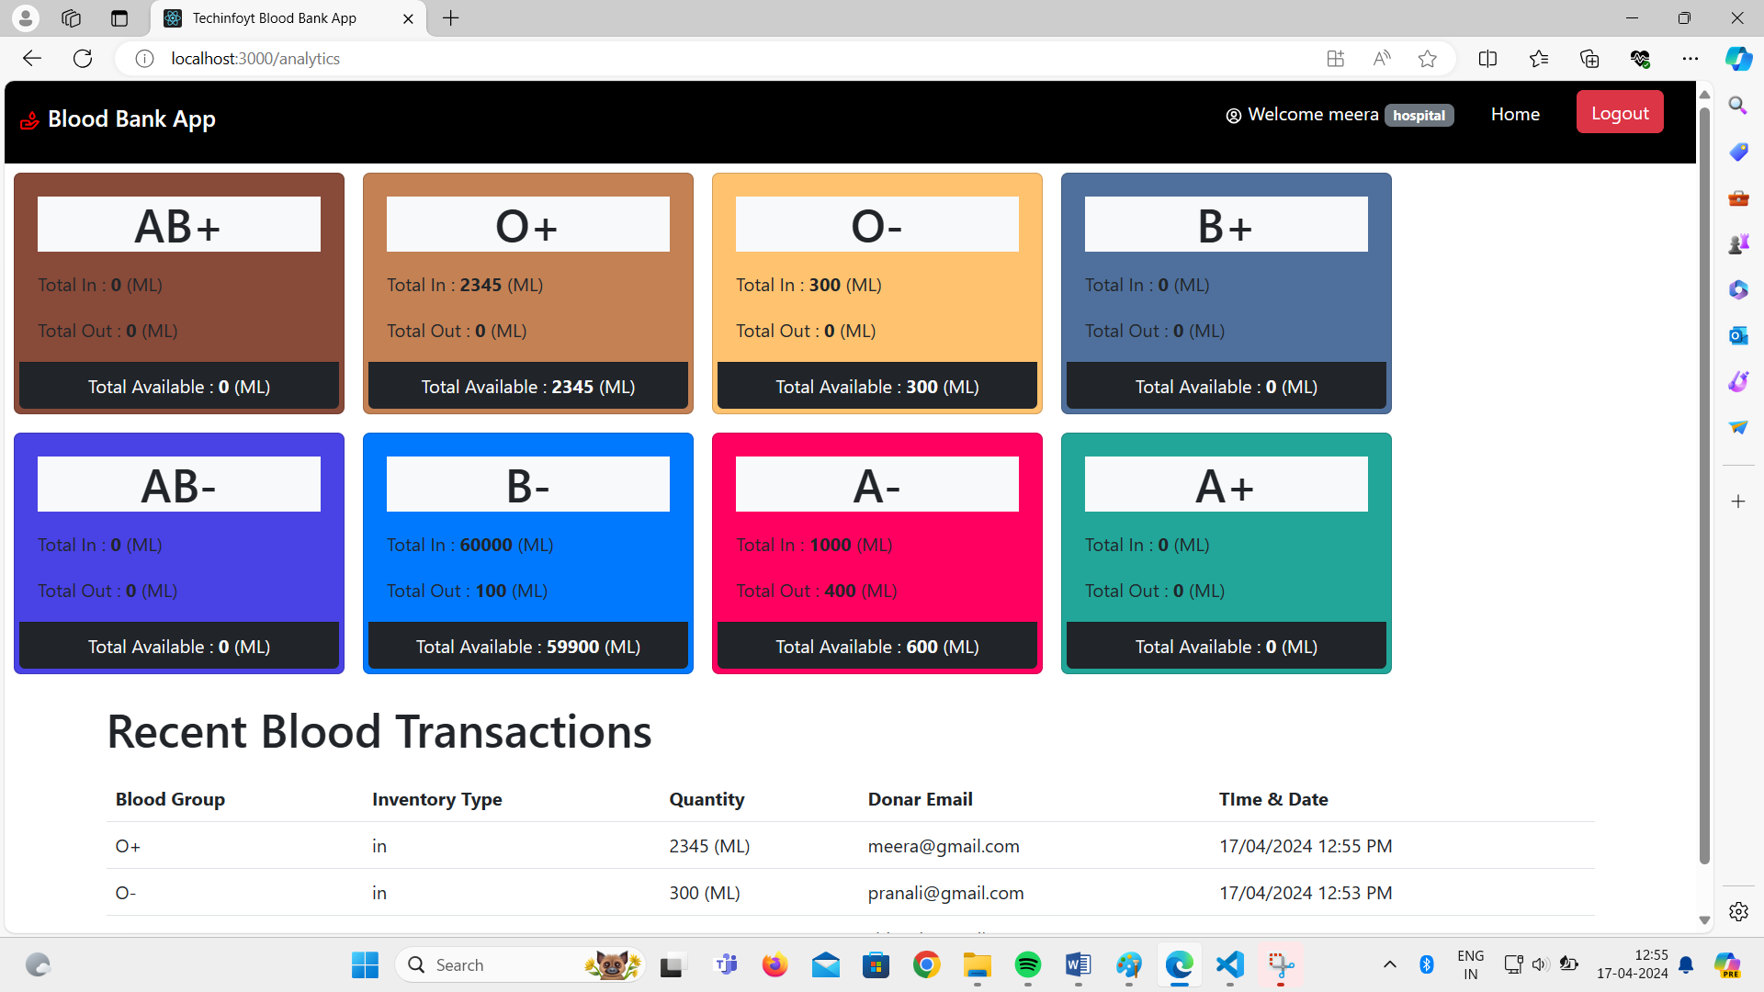

**Figure5.3: Blood Transaction**

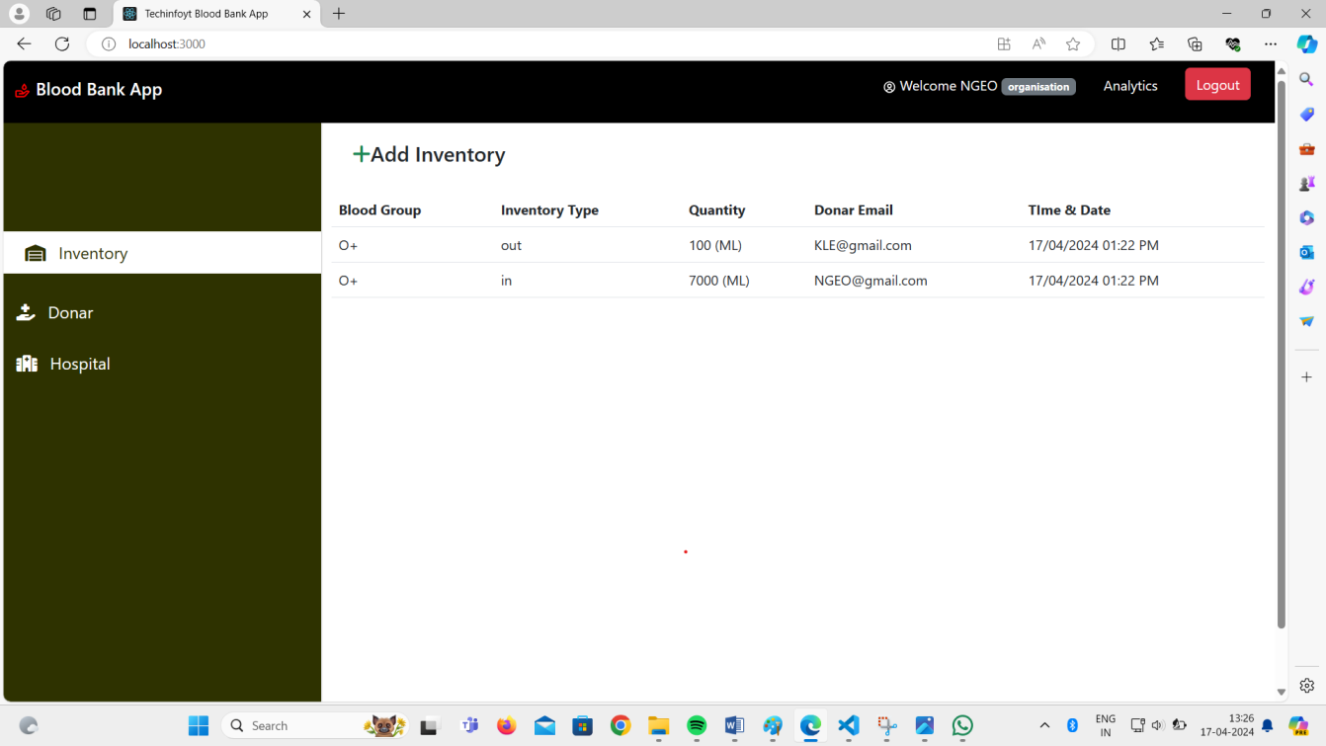

**Figure5.4: Organization Inventory**

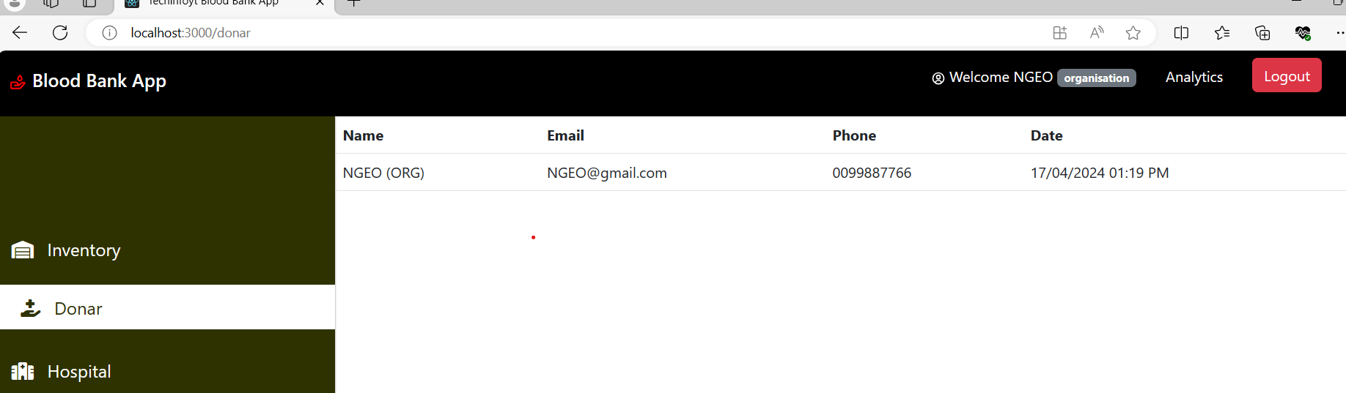

**Figure5.5: Organization Donar page**

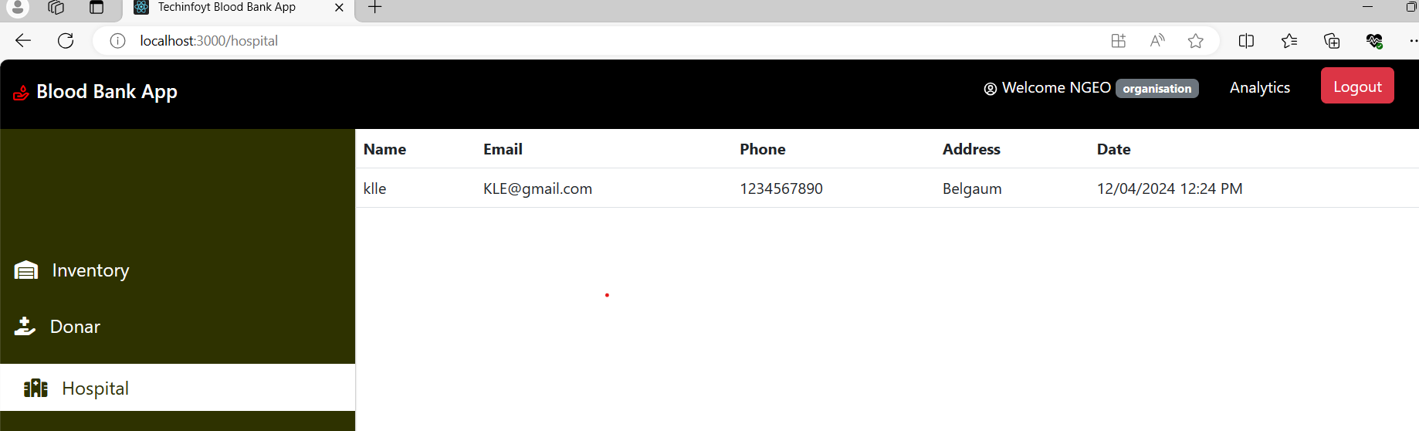

**Figure5.6: Hospital Organization page**

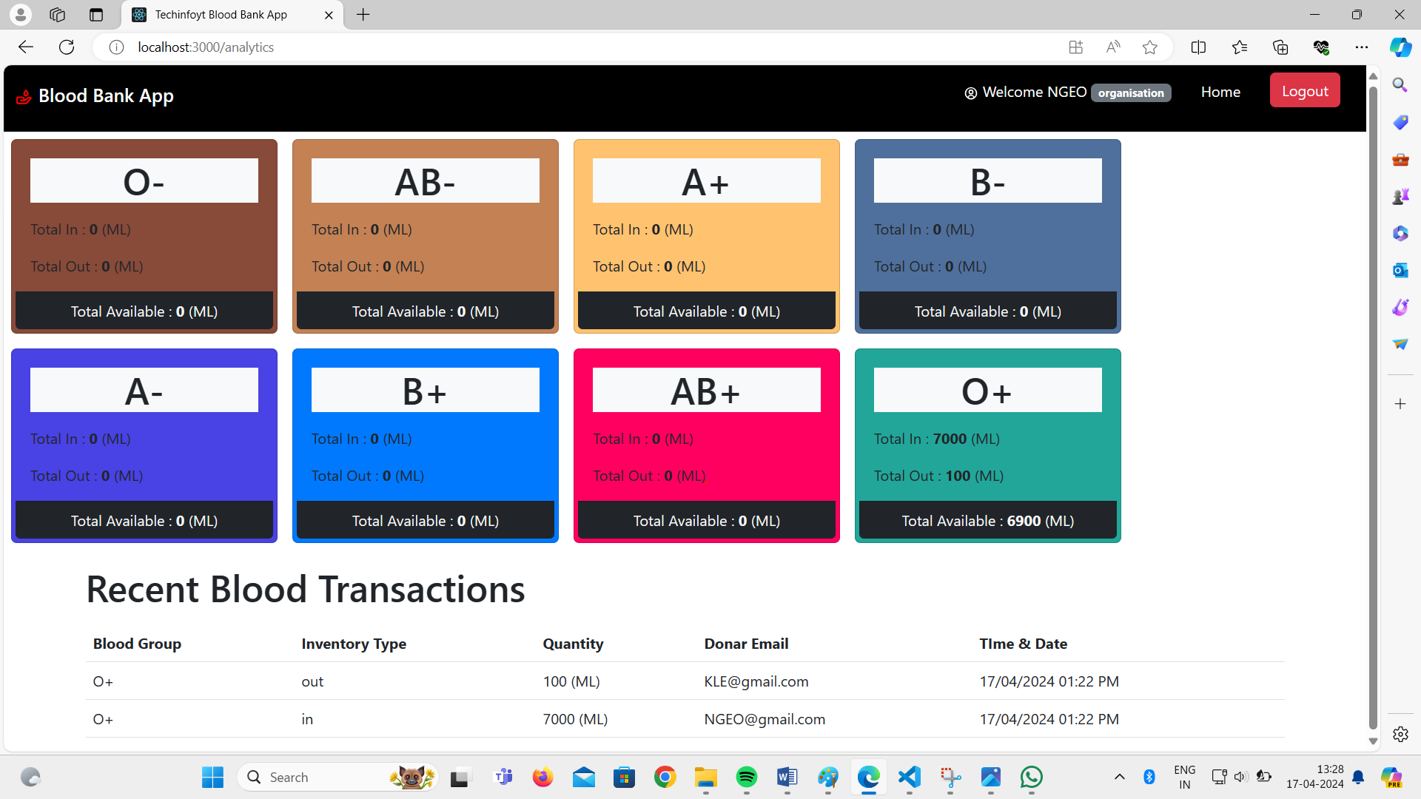

**Figure5.7: Organization Blood Transitions**

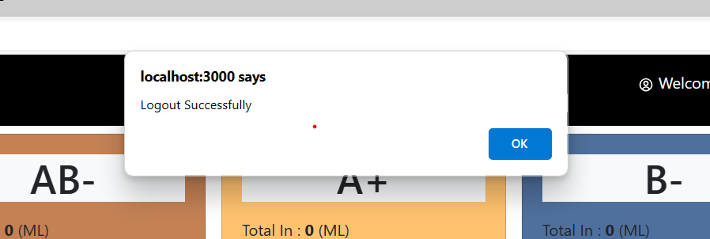

**Figure6: Logout page**

* **Conclusion:**

The purpose of these literature reviews was to collect information on how an information system helped the management of blood banks. Based on the reviews, it was found out that web-based blood bank systems provide convenience, efficiency and security to the system users and hospitals compared to the manual systems. It was found out that manual systems have many disadvantages that disappoint and dissatisfy users. Indeed, online blood bank applications make work easy, and ensures fast retrieval of data when needed.